ANJ VB

1. Read and match.
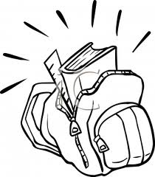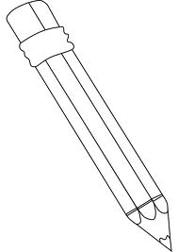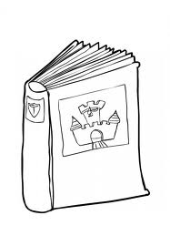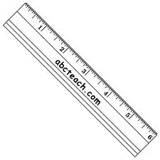

pencil books ruler school bags

rubbers pen colouring pencils pencil case

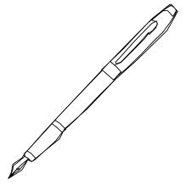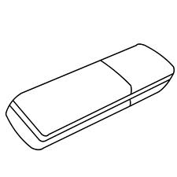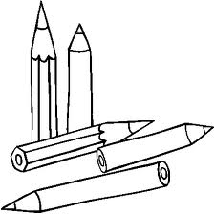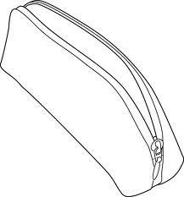

2. Write the sentences and answer about yourself: Yes, I have. No, I haven´t.

a ball? Have got you 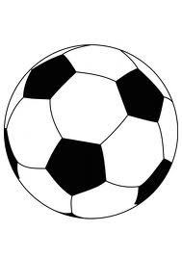 __________________________________________

_______________________
you got Have a bike? 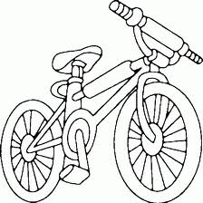 __________________________________________

________________________
Have you a skateboard got? 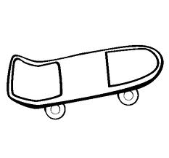________________________________________

________________________

got Have you a scooter? 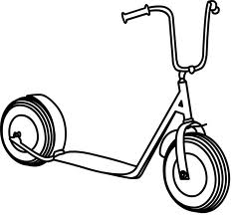 __________________________________________

__________________________

5. Write the numbers.

ninety-two ______ twenty-three ______ seventy-six ______
thirty-five ______ eleven ______ forty-one ______
a hundred ______ eighty-nine ______ fifty-five _____

6. Read and write or .
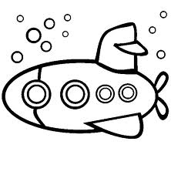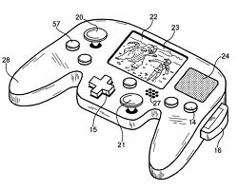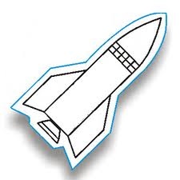
What are these? What are these? What´s this?
They´re submarines. It´s a computer game. It´s a rocket.

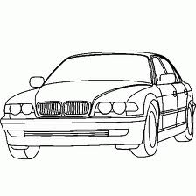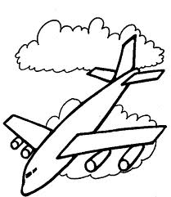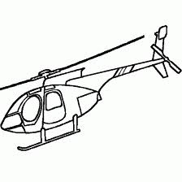

What are these? What´s this? What´s this?
They´re cars. It´s planes. It´s a helicopter.

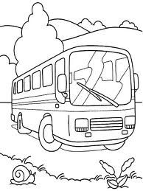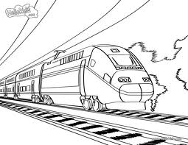

What´s this? What are these?
It´s a bus. They´re trains.

