Matematika 1.B

|  |  |  |  |  |  |
| --- | --- | --- | --- | --- | --- |
| 12 + 6 = | 11 + 8 = | 13 + 5 = | 10 + 9 = | 15 + 2 = | 18 + 0 = |
| 14 + 6 = | 10 + 8 = | 13 + 3 = | 17 + 3 = | 19 + 1 = | 7 + 3 = |
| 19 + 0 = | 11 + 5 = | 14 + 4 = | 16 + 2 = | 14 + 3 = | 15 + 5 = |
| 13 + 2 = | 20 + 0 = | 15 + 4 = | 12 + 4 = | 11 + 7 = | 17 + 0 = |
| 19 – 5 = | 17 – 3 = | 19 – 2 = | 19 – 10 = | 19 – 8 = | 20 – 10 = |
| 18 – 6 = | 17 – 2 = | 18 – 10 = | 16 – 4 = | 12 – 10 = | 17 – 5 = |
| 17 – 4 = | 17 – 1 = | 14 – 10 = | 12 – 2 = | 18 – 2 = | 13 – 2 = |
| 20 – 7 = | 20 – 2 = | 17 – 10 = | 11 – 0 = | 16 – 10 = | 10 – 8 = |

Usporiadaj čísla od najväčšieho po najmenšie:

8, 6, 12, 18 ,10 , 3 , 16 , 2, ___________________________________

6, 11, 5, 3, 19, 14, 17, 13, ___________________________________

Usporiadaj čísla od najmenšieho po najväčšie:

16, 14, 2, 5 ,11, 19 , 3 , 7, ____________________________________

19, 13, 6, 4, 7, 18, 14, 10, ____________________________________

|  |  |  |
| --- | --- | --- |
| 7 + 3 = | 5 + 0 = | 8 + 0 = |
| 7 – 3 = | 6 – 6 = | 9 – 4 = |
| 10 + 5 = | 8 + 10 = | 10 + 6 = |
| 6 + 10 = | 10 + 10 = | 7 + 10 = |
| 16 – 10 = | 13 – 10 = | 18 – 10 = |
| 15 – 5 = | 19 – 9 = | 12 – 2 = |
| 12 + 3 = | 14 + 1 = | 17 + 3 = |
| 13 – 2 = | 18 – 4 = | 16 – 3 = |
| 5 + 14 = | 6 + 12 = | 3 + 16 = |
| 20 – 4 = | 20 – 7 = | 20 – 18 = |
| 3 + 17 = | 6 + 14 = | 8 + 12 = |
| 20 – 13 = | 20 – 15 = | 20 – 6 = |
| 12 + 4 = | 16 + 3 = | 12 + 5 = |
| 15 – 2 = | 18 – 14 = | 18 – 3 = |
| 19 – 13 = | 17 – 5 = | 15 – 13 = |

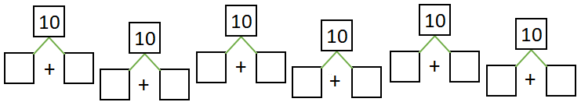

Doplň číselný rad....

